Princeton Plasma Physics Laboratory
NSTX Experimental Proposal
Title: Sustainment of HHFW-Driven 100% Non-Inductive H-Mode Plasma
OP-XP-1010 | Revision: 1 | Effective Date:  (Approval date unless otherwise stipulated)  Expiration Date:  (2 yrs. unless otherwise stipulated)
PROPOSAL APPROVALS
Responsible Author: G. Taylor |  |  | Date
ATI – ET Group Leader: G. Taylor |  |  | Date
RLM - Run Coordinator: E. Fredrickson |  |  | Date
Responsible Division: Experimental Research Operations
RESTRICTIONS or MINOR MODIFICATIONS
(Approved by Experimental Research Operations)

NSTX EXPERIMENTAL PROPOSAL
TITLE: Sustainment of HHFW-Driven 100% Non-Inductive H-Mode Plasma | No. OP-XP-1010
AUTHORS: G. Taylor, D. Mueller, J.C. Hosea, S. Gerhardt, C. Kessel, B.P. LeBlanc, C.K. Phillips, S. Zweben, R. Maingi,  P.M. Ryan, R. Maingi | DATE:  January 28, 2010

1. Overview of planned experiment
Use solenoid to ramp I_{p} to 300-400 kA, and then couple ~ 5 MW of HHFW heating to drive plasma into
H-mode, generating ~ 100% of I_{p} via boostrap current. This experiment should be run after XP-1009, and only when ~ 5 MW of HHFW has been successfully coupled into deuterium plasma. This experiment contributes to the NSTX research milestone R10-2.

2. Theoretical/ empirical justification
A goal of the NSTX program is to demonstrate 100% non-inductive H-mode plasmas. 85% bootstrap current fraction was achieved in XP-521 by coupling 2.5 MW of -14 + -18 m⁻¹ (180º) HHFW power into an I_{p} = 250 kA deuterium plasma. It should be possible to achieve 100% bootstrap current fraction with
~ 5 MW of RF coupled into an I_{p} ~ 400 kA discharge.

3. Experimental run plan
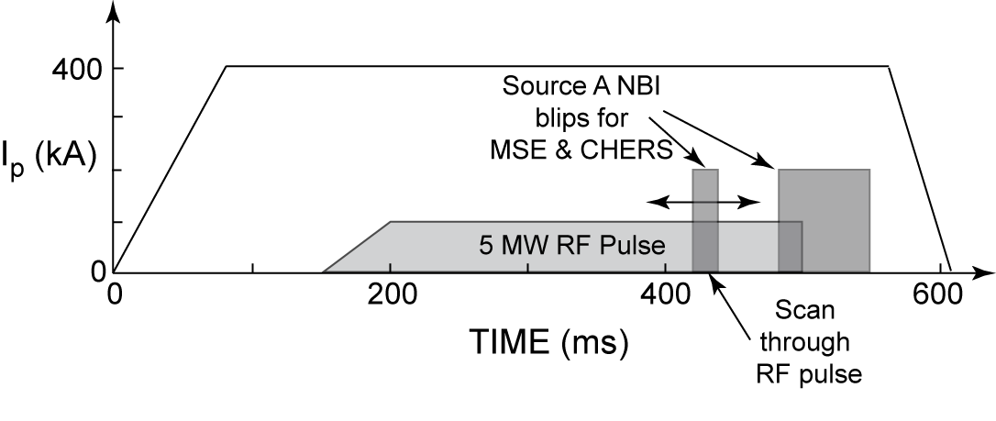
This experiment should take 1 day to complete.
1. Setup 600 ms I_{p} flattop plasma, similar to 123712 (B_{T} = 5.5 kG, deuterium), but with
I_{p} = 300-400 kA. (5 shots)
2. Add k_{φ} = 14 + 18 m⁻¹ -8 m⁻¹ (180º) HHFW power, coupled from 150 – 500 ms, with a 50 ms ramp-up in power at the start of the RF pulse. Increase RF power to 5 MW, while adjusting lithium evaporation rate, gas injection rate and outer gap to optimize HHFW heating efficiency. (10 shots)
3. Repeat with k_{φ} = (-90º) heating (10 shots)

4. Required machine, NBI, RF, CHI and diagnostic capabilities
This experiment should follow XP-1009, and requires P_{RF} ~ 5 MW at -14 + -18 m⁻¹and -8 m⁻¹. This experiment needs rtEFIT isoflux control for the outer gap. LITERs are required, but the LLD can be maintained in “cold”, solid lithium state. An NBI blip from source A at 90 keV should be added for MSE and CHERS data acquisition from 480 to 550 ms. In addition a 20 ms NBI blip from source A at 90 keV will be scanned through the RF pulse once good, reproducible, ~ 5 MW RF heating has been established. Thomson scattering data are required for core and edge electron heating data. For analysis of edge power loss and coupling efficiency the experiment also requires SOL reflectometry and edge ion heating data from edge rotation diagnostic.

5. Planned analysis
Planned analysis includes analysis of heating efficiency at k_{φ} = -8 m⁻¹ and -14 + -18 m⁻¹, TRANSP and GENRAY/CQL3D modeling.

6. Planned publication of results

The results will be submitted for publication in Nuclear Fusion or Physics of Plasmas, and may contribute to an HHFW IAEA paper.

PHYSICS OPERATIONS REQUEST
TITLE: Sustainment of HHFW-Driven 100% Non-Inductive H-Mode Plasma | No. OP-XP-1010
AUTHORS: G. Taylor, D. Mueller, J.C. Hosea, S. Gerhardt, C. Kessel, B.P. LeBlanc, C.K. Phillips, S. Zweben, R. Maingi,  P.M. Ryan, R. Maingi | DATE:  January 28, 2010

Brief description of the most important operational plasma conditions required:
Stable, reproducible I_{p} = 300-400 kA deuterium plasma with outer gap = 0.05 – 0.1 m.
Request D. Mueller as operator.
Previous shot(s) which can be repeated:
Previous shot(s) which can be modified: 123712
Machine conditions (specify ranges as appropriate, strike out inapplicable cases)
I_{TF} (kA): 66 Flattop start/stop (s): 0/0.7
I_{P} (MA): 0.4 Flattop start/stop (s): 0.08/0.6
Configuration: LSN
Equilibrium Control: Outer gap / Isoflux (rtEFIT) / Strike-point control (rtEFIT)
Outer gap (m): 0.05-0.1 Inner gap (m): Z position (m): 0.0
Elongation: Triangularity (U/L): OSP radius (m):
Gas Species: D Injector(s):
NBI Species: D Voltage (kV) A: 90 B: C: Duration (s): 480-550 ms, and
20 ms blip stepped between 250 to 450 ms from shot to shot
ICRF Power (MW): 5 Phase between straps (°): ±90, 180 Duration (s): 0.35
CHI: Off Bank capacitance (mF):
LITERs: On Total deposition rate (mg/min): 20 mg/min to start, adjust as needed
LLD: Cold Temperature (°C):
EFC coils: Off Configuration: Odd / Even / Other
DIAGNOSTIC CHECKLIST
TITLE: Sustainment of HHFW-Driven 100% Non-Inductive H-Mode Plasma | No. OP-XP-1010
AUTHORS: G. Taylor, D. Mueller, J.C. Hosea, S. Gerhardt, C. Kessel, B.P. LeBlanc, C.K. Phillips, S. Zweben, R. Maingi,  P.M. Ryan, R. Maingi | DATE:  January 28, 2010

Note special diagnostic requirements in Sec. 4
Diagnostic | Need | Want
Beam Emission Spectroscopy
Bolometer – divertor | √
Bolometer – midplane array | √
CHERS – poloidal | √
CHERS – toroidal | √
Dust detector
Edge deposition monitors
Edge neutral density diag. |  | √
Edge pressure gauges |  | √
Edge rotation diagnostic | √
Fast cameras – divertor/LLD
Fast ion D_alpha - FIDA
Fast lost ion probes - IFLIP
Fast lost ion probes - SFLIP
Filterscopes | √
FIReTIP |  | √
Gas puff imaging – divertor
Gas puff imaging – midplane |  | √
Hα camera - 1D |  | √
High-k scattering
Infrared cameras | √
Interferometer - 1 mm |  | √
Langmuir probes – divertor |  | √
Langmuir probes – LLD
Langmuir probes – bias tile
Langmuir probes – RF ant. |  | √
Magnetics – B coils | √
Magnetics – Diamagnetism | √
Magnetics – Flux loops | √
Magnetics – Locked modes | √
Magnetics – Rogowski coils | √
Magnetics – Halo currents | √
Magnetics – RWM sensors | √
Mirnov coils – high f. | √
Mirnov coils – poloidal array | √
Mirnov coils – toroidal array | √
Mirnov coils – 3-axis proto. | √
Note special diagnostic requirements in Sec. 4
Diagnostic | Need | Want
MSE | √
NPA – E||B scanning |  | √
NPA – solid state |  | √
Neutron detectors |  | √
Plasma TV | √
Reflectometer – 65GHz
Reflectometer – correlation
Reflectometer – FM/CW
Reflectometer – fixed f
Reflectometer – SOL | √
RF edge probes | √
Spectrometer – divertor | √
Spectrometer – SPRED | √
Spectrometer – VIPS | √
Spectrometer – LOWEUS
Spectrometer – XEUS |  | √
SWIFT – 2D flow
Thomson scattering | √
Ultrasoft X-ray – pol. arrays | √
Ultrasoft X-rays – bicolor | √
Ultrasoft X-rays – TG spectr.
Visible bremsstrahlung det. | √
X-ray crystal spectrom. - H |  | √
X-ray crystal spectrom. - V |  | √
X-ray tang. pinhole camera |  | √

