Princeton Plasma Physics Laboratory
NSTX-U Experimental Proposal
Title:
OP-XP- | Revision: 0 | Effective Date:  (Approval date unless otherwise stipulated)  Expiration Date:  (2 yrs. unless otherwise stipulated)
PROPOSAL APPROVALS
Responsible Author: |  |  | Date
SG, TSG or TF Leader (assigned by RC): |  |  | Date
Run Coordinator (RC): |  |  | Date
Responsible Division: Experimental Research Operations
RESTRICTIONS or MINOR MODIFICATIONS
(Approved by Experimental Research Operations)

NSTX-U EXPERIMENTAL PROPOSAL
TITLE: | No. OP-XP-
AUTHORS: | DATE:

Text in red is instructional: REMOVE IT from your final document

1. Overview of planned experiment
Briefly describe the scientific goals of the experiment.

2. Theoretical/ empirical justification
Brief justification of activity, including supporting calculations as appropriate. Describe briefly any previous or related experiments.

3. Experimental run plan
Describe experiment in detail, concentrating on specifying scans, decision points and processes.

4. Required machine, NBI, RF, CHI and diagnostic capabilities
Describe any prerequisite conditions, development, XPs or XMPs needed.
(you must also complete the Physics Operations Request and Diagnostic Checklist)

5. Planned analysis
What analysis of the data will be required: EFIT, TRANSP, specialized diagnostic analysis, modeling with impurity, edge transport or gyro-kinetic codes etc.?

6. Planned publication of results
What will be the final disposition of the results; where will results be published and when?

7. Estimated Neutron Production
Based on the number of shots, plasma current levels, and expected durations, estimate the maximum neutron production of this experiment. See calculator in Appendix #2 for this calculation.
# of Shots used in Estimate:________ Estimated Total Neutron Production:________________
PHYSICS OPERATIONS REQUEST
TITLE: | No. OP-XP-
AUTHORS: | DATE:
(use additional sheets and attach waveform diagrams if necessary)
Brief description of the most important operational plasma conditions required and any special hardware requirement:
Previous shot(s) which can be repeated:
Previous shot(s) which can be modified:
Machine conditions (specify ranges as appropriate, strike out inapplicable cases)
B_{T} Range (T): Flattop Duration (s):
I_{P} Range (MA): Flattop Duration (s):
Configuration: Limiter / DN / LSN / USN
Equilibrium Control: Outer gap / Isoflux (rtEFIT) / Strike-point control (rtEFIT)
Outer gap (m): Inner gap (m): Z position (m):
Elongation: Triangularity (U/L): OSP radius (m):
Gas Species: Injector(s):
NBI Species: D Heating Duration (s):
Voltage (kV) 50 cm (1C): 60 cm (1B): 70 cm (1A):
Voltage (kV) 110 cm (2C): 120 cm (2B): 130 cm (2A):
ICRF Power (MW): Phase between straps (°): Duration (s):
CHI: Off / On Bank capacitance (mF):
LITERs: Off / On Total deposition rate (mg/min) or dose per discharge (mg):
EFC coils: Off/On

DIAGNOSTIC CHECKLIST [1]
TITLE: | No. OP-XP-
AUTHORS: | DATE:

Note special diagnostic requirements in Sec. 4
Diagnostic | Need | Want
Beam Emission Spectroscopy
Bolometer – midplane array
CHERS – poloidal
CHERS – toroidal
Divertor Bolometer (LADA)
Divertor visible cameras
Dust detector
Edge deposition monitors [2]
Edge neutral density diag.
Edge MIGs [2]
Penning Gauges [2]
Edge rotation diagnostic
Fast cameras – divertor [2]
Fast ion D_alpha - poloidal
Fast ion D_alpha - toroidal
Fast lost ion probes - IFLIP
Fast lost ion probes - SFLIP
Filterscopes [2]
FIReTIP
Gas puff imaging – divertor
Gas puff imaging – midplane
Hα cameras - 1D [2]
Infrared cameras [2]
Langmuir probes – divertor
Langmuir probes – RF
Langmuir probes – RF ant.
Magnetics – Diamagnetism
Magnetics – Halo currents
Magnetics – RWM sensors

Note special diagnostic requirements in Sec. 4
Diagnostic | Need | Want
MAPP
Mirnov coils – high f.
Mirnov coils – toroidal array
MSE-CIF
MSE-LIF
Neutron detectors [2]
Plasma TV
Reflectometer – 65GHz
Reflectometer – correlation
Reflectometer – FM/CW
Reflectometer – fixed f
Reflectometer – SOL
SSNPA [2]
RF edge probes
Spectrometer – divertor
Spectrometer – MonaLisa
Spectrometer – VIPS
Spectrometer – LOWEUS
Spectrometer – XEUS
TAE Antenna
Thomson scattering
USXR – pol. Arrays
USXR – multi-energy
USXR – TG spectr.
Visible Brems. det. [2]

Notes:

[1] Check marks in this table do not guarantee diagnostic availability. Check with diagnostic physicists or research operations management to ensure diagnostic coverage.

[2] In some cases, a given line represents multiple diagnostics. For instance, there are multiple SSNPAs, multiple IR cameras, multiple neutron detectors, and multiple Langmuir probe arrays.

Appendix #1: Allowed Neutral Beam Power vs. Pulse Duration

Heating of the primary energy ion dump limits the beam duration to that given in the following table:
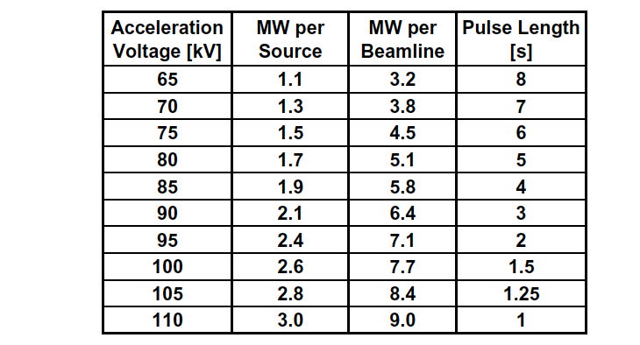
Table A1: Beam power and pulse length as a function of acceleration voltage

Appendix #2: Table for neutron rate estimations:

Table A2: Neutron Emission Rate Calculator. Double click to open in excel for automatic calculation. Change only the blue cells.

J.E. Menard, et al., Nuclear Fusion 52, 2012 (83015)

